Istio service:
What?
Istio is a service-to-service communication tool also called east-west traffic management tool it connects between the services.
Why:
Before istio there is no tls in btw the services
There is other ways to connect btw the services but istio gives some add ons
on mTLS(mutual TLS) service means it can secure service to service communication every service will have a certificate generated by istio.
It also gives advance deployment strategies like canary,blue-green in a very easy way.
Istiod is the main component performs control plane related to istio and all the main concepts of istio.
It also comes with kiali observability.it keeps a track of service to service to communication
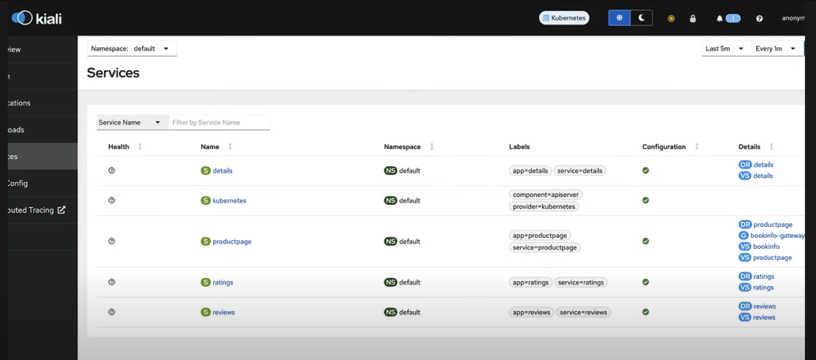

How?
Within each and every pod istio will add a side car container. inside this side car container there is an envoy proxy app. It is proxy server. It handles the traffic management of pod.every request will go through the side car container.
Mtls works through side car container.
If someone sends a request to the api server for a pod creation istio will get notified to add a side car container or not by using admission controllers there is advance option called dynamic admission controller or admission webhook.
Admission controller will validate or modify few things in the pod resource or any resource that is gtg created.
Api server already has 30+ admission controller. we can enable or disable them.
Istio runs mtls in the permissive mode the permissive mode says u can either the service using mtls or u can also access it without using mtls.
Virtual service and destination rules will help us in implementing canary model of deployment.
